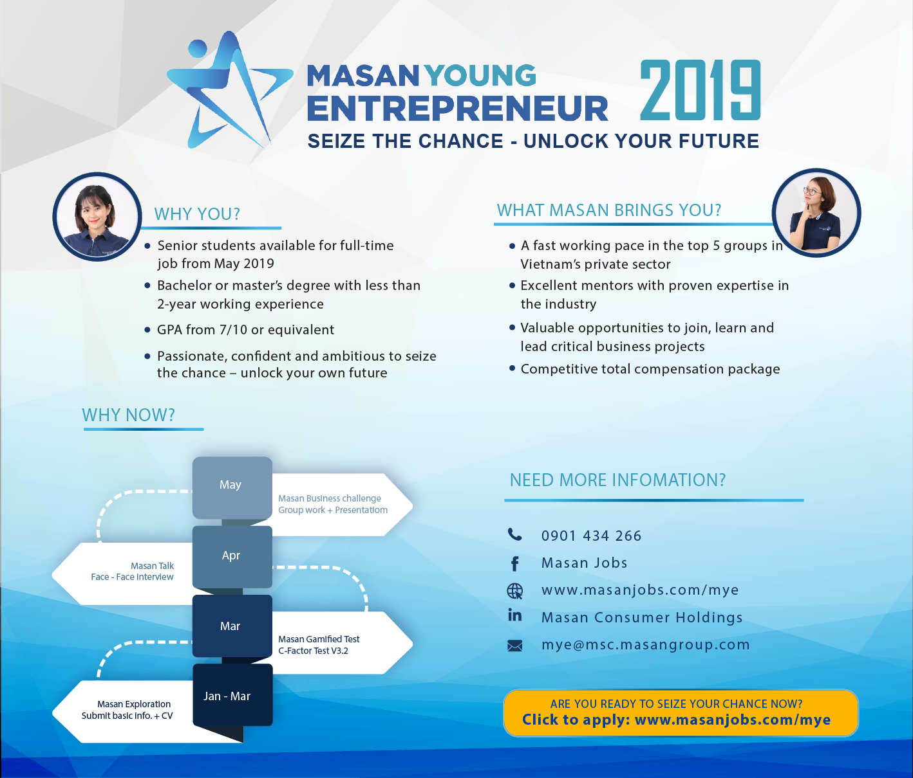

MASAN YOUNG ENTREPRENEUR 2019 IS BACK!

Masan Group is among the top biggest private sector groups in Vietnam. Founded in 1996 and is headquartered in Ho Chi Minh City, our subsidiaries include Masan Consumer (FMCG), Masan Resources (Mining) and Masan Nutri Science (Agriculture-Food). Masan is well-known as company with the best M&A strategy of the decade, among top listed companies reported by Forbes.

Our Masan Young Entrepreneur (MYE) is the unique program that aims to invest, nurture and empower Vietnamese young talents who are willing to seize the opportunities - unlock their future to become Masan-Leaders-to-be with the passion to contribute their values for a better Vietnam.

With 5 recruiting seasons, there is thousands of Vietnamese millennials have been interested in the program, over 50 talents have become Masan Young Entrepreneurs. In the 6th season, Masan Group offers countrywide MYE’s opportunities at below departments: Sales, Marketing, Finance, Supply Chain, R&D, HR, Legal, MPO (Procurement)

WHAT MASAN BRINGS YOU?
- A fast working pace in the top 5 groups in Vietnam’s private sector
- Excellent mentors with proven expertise in the industry
- Valuable opportunities to join critical business projects
- Competitive total compensation package

WHY YOU?
- Senior students available for full-time job from May 2019
- Bachelor or master’s degree with less than 2-year working experience
- GPA from 7/10 or equivalent
- Passionate, confident and ambitious to seize the chance – unlock your own future

MYE 2019 SELECTION PROCESS?
- Stage 1: Masan Exploration
- Stage 2: Masan Gamified Test
- Stage 3: Masan Talk
- Stage 4: Masan Business Challenge

ARE YOU READY TO UNLOCK YOUR FUTURE?
Seize your chance, now: www.masanjobs.com/mye

