Wind power – green renewable energy
Energy is one of the essential demands of human and socio-economic development. With the enhance of living standard and economic production, the requirement for energy is also increase which is challenge for the most countries. Besides of the exploitation of traditional energy sources, the renewable energies have to fully exploited to bring the highest efficiency in term of economy, natural sources and resources and social environment.
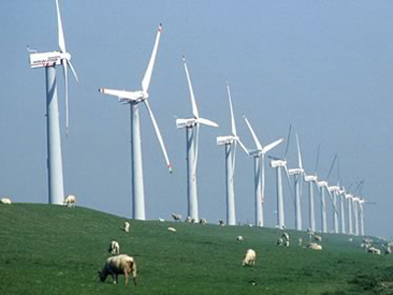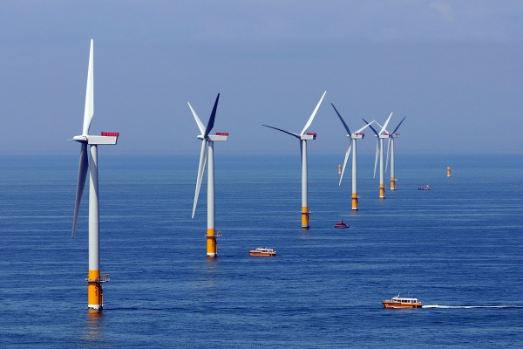
Wind energy is a renewable and endless energy source which always active and exists base on natural law. Exploitation wind power will reduce the use of non-renewable energy sources such as coal, wood, ect. to avoid exhausting natural resources and satisfy the sustainable development trend of energy of country. Thought reducing emission into the atmosphere, using wind power can prevent the global climate change. With low requirement for using land area, the construction of wind power plant can save land to use for agriculture activities. One of biggest advantages of wind energy is low of investment, operation and electricity costs.
Vietnam is located in the monsoon subtropical climate region with a long coastline which is a fundamental advantage for developing wind energy. According to the world bank of energy assessment program for Asia in the four surveyed countries, Vietnam has largest wind potential compared to neighboring countries such as Thailand, Laos and Cambodia. The high potential for building wind power plant occupy 8.6% area of territory which fit on build large scale of plants. With favor of geographic position in the energy development strategy, the wind power will be a key energy source in Vietnam that service for the socio-economic development, resource environment protection and catch up trend of world energy development.

